Exploiting Parallelism for FPGA Designs

David Robert Clarke

B.Eng Electrical & Electronic Engineering

Dr D.J.Holding

Electrical & Electronic Engineering,
School of Engineering and Applied Science,
Aston University.

05/2001

Project Specification

Aim of Project

To investigate, design and build a FPGA based matrix multiplier, which would be used in alternative serial and parallel matrix multiplication. The system researched will be used to monitor the processing speed difference between the two entities. In the latter stages, partitioning techniques involved in parallel matrix multiplication operations will also be studied.

Objectives

- To Investigate and develop a VHDL scripted algorithm which implements the matrix multiplier

- To investigate various architecture devices

- To Interface the FPGA-based design to a computer monitor

- To stimulate the FPGA design with test signals using a test bench environment

Schedule of Work

- Software

  - To develop a VHDL based design of the matrix multiplier entity and architecture.

  - Study what/how different partitioning techniques on data and investigate how they can be used to get the most productive parallel multiplicative result.

- Research

  - Study into which architectures will give the most effective multiplicative results.

- Interface

  - To investigate how the separate matrices can be inputted from the user and sent to the FPGA-based design.

  - To investigate how the timing data and matrix multiplication results from the FPGA-based design can be outputted and displayed.

4 Test bench

  - To verify that the FPGA-based design behaves accurately.

4.2 Carry out studies to test the full extent of the FPGA-based design's processing power.

Acknowledgements

The author would like to thank Dr. D.J.Holding, Mr. M.S.Wrenn and Mr. Robert Cairns for fruitful discussions and comments.

List of Contents

1 Synopsis Page 5

2 Introduction Page 6

3 Body of the Report

- Initial Thoughts Page 9
- The Partition - Design Page 12
- Configuration 1,2 & 3 – Design and Implementation Page 14
- Configurations Integrated – Design and Implementation Page 22
- Project 4x4 - Design Page 26
- Project 3x3 – Design and Implementation Page 29
  - Entity Data Store Page 33
  - Entity Inter Store Page 36
  - Entity Multipliers Page 37
  - Entity Adders Page 39
  - Entity Counter Page 40
  - Entity Answer Store Page 41
  - Entity Seven Segment Encoder Page 41
  - Entity Finite State Machine Page 43
  - Entity Config Inf Page 44
- Project 3x3 – Evaluation Page 54

4 Conclusion Page 58

5 References Page 60

6 Appendix A Explanation of Matrix Multiplication Page 61
7 Appendix B Manual Calculation of Test Matrices Page 63
8 Appendix C Display PCB Board Templates Page 71

Synopsis

The project investigates the exploitation of parallelism in digital systems and develops a VHDL scripted algorithm which implements a concurrent architecture in the form of the matrix multiplier. Each investigation uses top down digital design methodology. The finalised design implements both serial and parallel processing elements into a system code named “Project 3x3”. Various alternative architectures which could make up the matrix multiplier have been scrutinized in the latter stages of this report. The most effective form of the matrix multiplier was found to be the column of multipliers adders combination. This digital signal processing unit allowed separate concurrent processing of products and sums to produce the matrix product. Constraints were placed on the finalised design that helped condense it’s structure, allowing implementation onto the target FPGA possible. Interfacing with the FPGA-based design was a prime issue. Data was input to the system using a windows graphical user interface in the form of the WinXSport program. Even the product matrices were output to windows software, in this case a pod-a-lyzer probe. A number of different values were selected for the input matrices. These were executed using the four available matrix multiplications. The results achieved were in the form of the matrix product and processing count. From these results it was apparent that the processing power of the serial architecture notably decreased in comparison to the parallel architecture for larger matrix multiplications.

Introduction

Digital systems design has become of interest since initially studying this subject in the first year of the E&EE course. The 2nd year further developed knowledge of digital design, introducing a new design platform VHDL. VHDL is a Very high level Hardware Description Language, focused on describing digital systems for the purpose of simulation in tasks such as performance evaluation and design verification. This project would allow further develop knowledge of VHDL programming. Allowing designs to be generated for a unique application specific system on laboratory hardware such as the FPGA.
The basic idea underlying the architecture of an FPGA (Field Programmable Gate Array) is very simple. It is basically hardware that is programmable much in the same way one can change the instructions of a program.
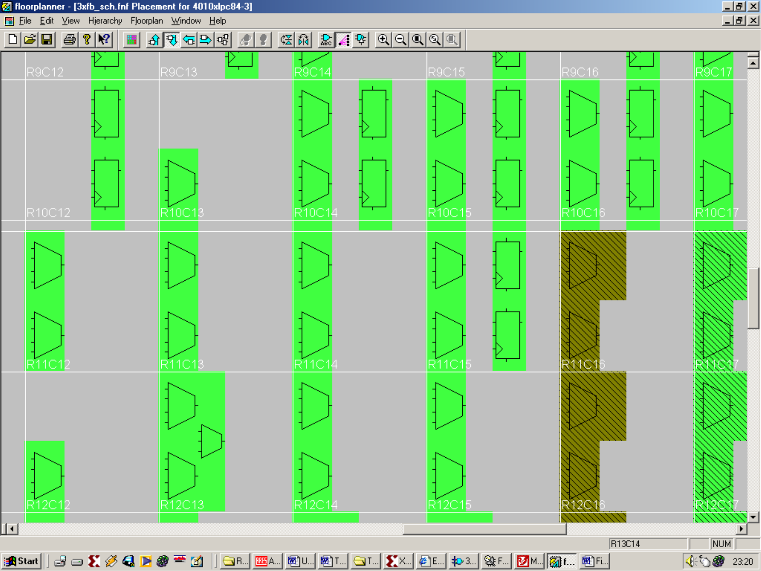
CLB

Figure A Sections of complex logic blocks in a standard FPGA

As shown in Figure A, the FPGA is made up of complex logic blocks (CLB’s) which are configured to implement different logic functions i.e. Combinational and sequential logic.

This project is focused on synthesising digital signal processing subsystems which will target FPGA’s. Creating a logic circuit for a FPGA usually consists of the following steps (depicted in Figure B):-

- Entering a description of the logic circuit using a hardware description language (HDL) such as VHDL.

- Use a logic synthesizer program to transform the HDL into a netlist. The netlist is just a description of the various logic gates in the design and how they are interconnected.

- Test the functions of the circuit by loading the netlist into a simulator, applying input patterns (known as test vectors), and observing the simulated outputs.

- Use implementation tools to map the logic gates and interconnections into the FPGA. The FPGA consists of an array of slices which can be further decomposed into configurable logic blocks (CLBs) that perform logic operations using a set of look-up tables (LUTs). The CLBs are interwoven with various local and global routing resources.

- Once the implementation is complete, the state of the routing switches and CLBs are extracted to create a bitstream.

- The bitstream is downloaded into a physical FPGA. The electronic switches in the device open or close in response to the binary bits in the bitstream. Upon completion of the downloading, the FPGA performs the operations specified by the HDL code. XILINX Foundation 2.1i provides the HDL editor, logic synthesizer, simulator, implementation tools, and bitstream generator software. The XSLOAD utility from XESS will download the bitstream into an XS40 FPGA Board.

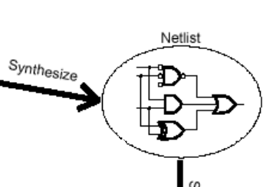
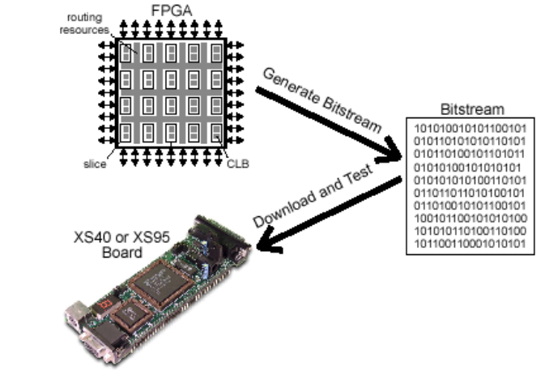
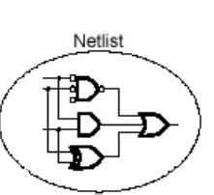
Synthesise
Generate Bitstream
Download and Test
Implement

Figure B Steps involved in creating and testing an FPGA based design
The end product should meet the following criteria. The VHDL script will target FPGA hardware. The finalised digital system must be able to perform matrix, matrix multiplication. The matrix multiplier should process matrix data in a concurrent fashion. A serial architecture will be created and tested against the developed concurrent parallel entity. The finalised system will test both the serial and parallel architectures with the same set of input matrices. The product matrix will be calculated, along with the processing power (no of clock cycles) required to achieve that answer.

The report is split into 8 Sections. Section 3, the Body of the Report, is split into 7 chapters. The initial chapter, Chapter 1 delves into concepts, initial thoughts on the general structure of the design. Chapter 2 details the first basic digital design called partition that attempts to answer the question of matrix multiplication through a low level abstraction approach. A design set at a much higher level of abstraction is described in Chapter 3. Configurations 123 addresses the issue of parallelism in three separate matrix multiplier systems working with differing levels of concurrency. Chapter 4 describes an alternative to Configurations 123. A system that emulates serial data processing in a parallel architecture. The complexity of the integrated system was increased to create a system that can multiply together 4x4 matrices as described in Chapter 5. Chapter 6 and 7 dealt with the finalised design, describing it’s general structure, methods of implementation and an overview on how it met with the specified objectives of the project.
The project is concluded in Section 4, where findings and recommendations are summarised. Section 5 states all the reference material used for research. Several appendices have been added to support the material in the text. Appendix A gives an overview of matrix multiplication. Appendix B shows manual calculations in full, for test performed on the finalised system. Appendix C holds the templates to PCB designs which would used to implement the display board for the finalised system. These appendices are found in Sections 6, 7 and 8 of this report respectively.

Body of the Report

CHAPTER 1 Initial Thoughts

Given the title of the project “Exploiting parallelism for FPGA designs,” a number of ideas initially came to mind. Reading further into the project description “to implement computationally intensive algorithms (such matrix multiplication) using essentially sequential data processing techniques.” It became clear from the start, the project would involve developing a system based around the mathematical operation, and non more protracted than that of matrix multiplication. How could parallelism be exploited in a matrix multiplication system? Answer, using parallel processing. Research would need to be undertaken in the issues surrounding matrix computations performed in a parallel system architecture. What test could be undertaken to exploit parallelism? Comparison of a serial DSP architecture against a developed parallel architecture. The key tests would be evaluating processing power (number of clock cycles) required to perform matrix multiplication using either serial or parallel architecture. With the aim of the project loosely in place, the initial design could now be developed.
Serial
Matrix
Multiplicative
Operation

Parallel
Matrix
Multiplicative
Operation
Matrices
Input
Output Answer
Output Operation time

FIGURE 1-1 Initial High Level Flow Diagram
A high level view of the design was drawn up (shown in Figure 1.1). The design flow shows that given two matrices, by choosing either to process the data in a serial or a parallel fashion, a matrix product will be achieved along with a value for the number of clock cycles required to process the data. Keeping in mind the high level flow diagram, the input, output and processes can be researched in turn.
The mathematics involved in matrix multiplication are simple, but tedious when considering higher order matrices. The Croft Davison Hargreaves “Engineering Mathematics” book explained clearly what was involved in such a matrix multiplication. This information was extracted and inserted into the Appendix A. The single most important fact, for matrix multiplication to take place the number of columns of matrix A must be the same as the number of rows of Matrix B. With this theory in mind; after the initial flow diagram, a second was drawn up (shown in Figure 1.2) which probes into the separate processes in more detail.
YES
Parallel
Serial
NO
Serial Matrix
Multiplicative Operation

Parallel Matrix
Multiplicative Operation
Output Answer
Output Operation time
Are Matrix A's columns of the same magnitude as Matrix B's rows ?
Produce an error message.
Redefine Matrices.
What method do want to use to find the product?
Input Matrix A's Parameters.
Input Matrix B's Parameters.
Start

FIGURE 1-2 Second High Level Flow Diagram
From the start, this digital design would be implemented using the hardware description language, VHDL. Knowledge gained from the 2nd Year VHDL course helped initially in the designs inception, however much was to be learnt about VHDL from this project.
The flow diagram of Figure 1.2 could now be realised initially in block diagram form.
Error_Output
Matrix_Input_A
Matrix_Input_B
Matrix_ B
Matrix _A
DSP_En
Size
Comparator

Finite State Machine
Digital Signal Processing
Output Answer
Output Operating time

FSM_
Enable

FIGURE 1-3 Very basic system which could implement the matrix multiplication algorithm.

Initial thoughts were, input matrices A and B’s data into the system in a serial fashion (the size of the matrices were not an issue). The first digital system to be met would be the size comparator. Matrix A’s data would be input first, the number of columns would be calculated and stored. Matrix B’s data would then be input, the number of rows would be calculated, stored and then compared against the value of Matrix A’s column size. If the two magnitudes did not match then the data flow would be halted and an error signal would be outputted. The finite state machine is surrounded in a dashed border to illustrate that it isn’t detailed but is involved in the next stage of the data flow process.
The design was becoming too large, too complicated, too fast, hence scraped. To ensure the behaviour of the system could be derived from first principles a simpler specification needed to be supplied.

CHAPTER 2 The Partition - Design

- This system would be required to multiply together two matrices. Matrix A and Matrix B would both have the dimensions 2 rows by 2 columns. An example of such matrices that need to be multiplied together are shown below.

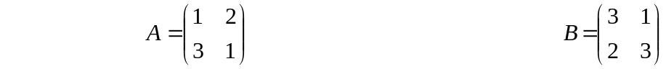
Matrix_A Matrix_B

- The magnitude of each element could not exceed the decimal value 3. Hence each element could be represented by a 2-bit binary number.

Figure 2.1 shows a design created with these ideas in mind. Storage elements such as latches would be required to gather data ready to be passed to the DSP. In this design the latches were looked at a very low level. Routing of signals through the hierarchy of individual latches that made up the storage element Entity was prioritised. The finite state machine would be looked at after the storage element was complete, this wasn’t to be.
Partition
_Out
Clr
Clk
Matrices
_In

FSM
Mem_SEL

Partitioner
Partitioner_En

Memory
(Latches)

DSP
Output Answer

FIGURE 2-1 Next phase of the very basic system which could implement the matrix multiplication algorithm.

I had reached a stage where the design model was becoming too low level, emphasis was put on structural design of the individual entities. In the designers mind, structural level based VHDL design would be the only way to implement this design. Again as further designs were developed, this wasn’t to be the case.
The two entities “the controller” and “controlled circuit” would need to be defined and created at a high level. A rethink was required, the system needed to be redesigned. To achieve the aim of the project the top down design methodology needed to kept simple. To keep ideas simple emphasis would need to be placed on the use of behavioural VHDL, this would keep the level of abstraction at a high enough level in order to create the individual digital entities. What the individual entities did, could be described and created. The manner of how the lower level components of the entity are structurally connected was of no concern. With this in mind, a transition to the next step of the design process could be made.

CHAPTER 3 Configuration 1,2 & 3 – Design and Implementation

With reference to the aim of the project, the extract “partitioning techniques involved in parallel matrix multiplication” was a major issue when designing this system. To exploit parallelism and partitioning of data in a parallel architecture; through further research a different design criteria was thought up. This new digital system would use three different matrix multiplier systems. Individual systems consisting of 2, 4 and 8 multipliers would be implemented. Indeed more multiplier configurations could be implemented i.e. >4, or even two, however, three systems would show results consisting of low, medium and high levels of processing.
Adopting a basic approach, the system would consist of

FSM Controller - FSM which enables logic functions to operate

DSP - the DSP alters the signal, i.e. processes the signal so it is in a different form

Inputs - Two matrices, Matrix A has 2 columns by 2 rows, Matrix B also has 2 columns by 2 rows. The magnitude of each element is known as shown below.

This data would be serially input into three different ASM controllers. Each ASM controller would operate in one of three ways:-

- Configuration one would comprise of an individual ASM Controller and DSP, the DSP would consists of two multipliers.

- Configuration two would comprise of an individual ASM Controller and DSP, the DSP would consist of four multipliers.

- Configuration three would comprise of an individual ASM Controller and DSP, the DSP would consist of eight multipliers.

Shown below is a very high level view of how the three processors would look:
ASM Controller
Matrix Input
Matrix Multiplication
Answer calculated in time T1
Matrix Multiplication
Answer calculated in time T3
DSP (2xMultiplier)
ASM Controller
DSP (4xMultiplier)
ASM Controller
DSP (8xMultiplier)
Matrix Multiplication
Answer calculated in time T2

FIGURE 3-1 Highest level Look at the Matrix Multiplier Configurations

Some questions might obviously be raised. Why are three separate configurations being tested?

Answer: If three configurations were culminated into one ASM controller with one DSP, there could be some problems. Firstly the single ASM controller and DSP would have logic (which is redundant for some configurations and active for others) this extra logic could unheedingly slow down the processing of data . Hence the processing time results would be difficult to differentiate for the three different configurations.
Having three processors working on the data at the same time would show in one sitting will show what the difference in the processing speeds are. There would be no need to re-enter the matrix data for a second or third time in order to calculate the Matrix product for a different configuration. The three configurations are shown in more detail in Figures 3.2, 3.3 & 3.4.

Matrix A
Data Element
Matrix B
Data Element
Matrix B
Data Element
Matrix A
Data Element
A(2)xB(1) + A(3)xB(3)
A(2)xB(0) + A(3)xB(2)
A(0)xB(1) + A(1)xB(3)
A(0)xB(0) + A(1)xB(2)
TWO 4-BIT DATA BUSES HOLDS MATRIX DATA ELEMENT PRODUCT
8-BIT
Elemental Data Bus
Matrix A and Matrix B data

2-BIT
MULTIPLIER
MULTIPLIES TOGETHER TWO SETS OF MATRICES ELEMENT DATA BITS TO FORM THE MATRIX DATA ELEMENT PRODUCT

4-BIT
ADDER
THE MATRIX DATA ELEMENT PRODUCT WORDS ARE ADDED TOGATHER

MEMORY
STORES FOUR SETS OF SUM-OF PRODUCTS
5-BIT DATA BUS HOLDS SOP AND PRODUCTS
ALLOCATE DATA TO MEMORY LOCATION 1, 2, 3 OR 4

2-BIT
MULTIPLIER
MULTIPLIES TOGETHER TWO SETS OF MATRICES ELEMENT DATA BITS TO FORM THE MATRIX DATA ELEMENT PRODUCT

FSM CONTROLLER
CONFIGURATION_1
D-TYPE CLOCKING SIGNAL 4-BITS, WHEN LOW to HIGH, DATA at D IS STORED

Figure 3-2 Configuration 1, parallel processing system containing 2, 2-bit multipliers and a 4-bit adder

Matrix A and Matrix B
Data input
Matrix B
Data Element
Matrix B
Data Element
Matrix A
Data Element
Matrix A
Data Element
Matrix B
Data Element
Matrix A
Data Element
Matrix B
Data Element
Matrix A
Data Element
A(2)xB(1) + A(3)xB(3)
A(2)xB(0) + A(3)xB(2)
A(0)xB(1) + A(1)xB(3)
A(0)xB(0) + A(1)xB(2)
FOUR 4-BIT DATA
16-BIT
Elemental Data Bus

2-BIT
MULTIPLIER

4-BIT
ADDER

MEMORY
STORES FOUR SETS OF SUM-OF PRODUCTS
TWO 5-BIT DATA BUSES HOLD SOP AND PRODUCTS

FSM CONTROLLER
CONFIGURATION_2

2-BIT
MULTIPLIER

2-BIT
MULTIPLIER

2-BIT
MULTIPLIER

4-BIT
ADDER

D-TYPE CLOCKING SIGNAL, WHEN LOW to HIGH, DATA at D IS STORED

Figure
FIGURE 3-3 Configuration 2, parallel processing system containing 4, 2-bit multipliers and 2, 4-bit adder
EIGHT 4-BIT DATA BUSES
D-TYPE CLOCKING SIGNAL 4-BIT,WHEN LOW to HIGH, DATA at D IS STORED
Matrix A
Data Element
Matrix B
Data Element
Matrix B
Data Element
Matrix A
Data Element
Matrix A
Data Element
Matrix B
Data Element
Matrix A
Data Element
Matrix B
Data Element
Matrix A
Data Element
Matrix B
Data Element
Matrix A
Data Element
Matrix B
Data Element
Matrix A
Data Element
Matrix B
Data Element
Matrix B
Data Element
Matrix A
Data Element
A(2)xB(1) + A(3)xB(3)
A(2)xB(0) + A(3)xB(2)
A(0)xB(1) + A(1)xB(3)
A(0)xB(0) + A(1)xB(2)
32-BIT
Elemental Data Bus
Matrix A and Matrix B data serially Inputted
2-BIT
MUL

4-BIT
ADDER

MEMORY
STORES FOUR SETS OF SUM-OF PRODUCTS
FOUR 5-BIT DATA BUSES HOLD SOP AND PRODUCTS

FSM CONTROLLER
CONFIGURATION_3
4-BIT
ADDER

2-BIT
MUL

2-BIT
MUL

2-BIT
MUL

2-BIT
MUL

2-BIT
MUL

2-BIT
MUL

2-BIT
MUL

4-BIT
ADDER

4-BIT
ADDER

ALLOCATE DATA TO MEMORY LOCATION
1, 2, 3 OR 4

FIGURE 3-4 Configuration 2, parallel processing system containing 8, 2-bit multipliers and 4, 4-bit adder
How would the matrices data enter these configurations?

Data could easily be shifted in a serial manner then acted upon by the DSP (the matrix multiplier). Because the whole purpose of this project rested on the aspect of exploiting parallelism, data should also exploit this. So the matrices data would arrive at the input to the DSP in parallel, but where from? The easiest method, the method which was adopted, was the use of a memory element (ROM) prior to the DSP. In the realisation of this entity, data control signals would be sent from the ASM CONTROLLER to the memory module. Data in this memory module would then be placed on the data bus when required. To visualise the operation of the Configuration system so far, a schematic has been developed in Figure 3.5.
ELEMENT DATA BUS
unsigned (X downto 0)

DATA SELECT SIGNAL
Integer range (X downto 0)
LATCH_MEM SIGNAL
std_logic_vector
(X downto 0)
CLR

CLK

ASM CONTROLLER
CONFIGURATION_X

DSP

MEMORY
BLOCK
A0B0_A1B2
std_logic_vector
(4 downto 0)
A0B1_A1B3 std_logic_vector
(4 downto 0)
A2B0_A3B2
std_logic_vector
(4 downto 0)
A2B1_A3B3
std_logic_vector
(4 downto 0)
FIGURE 3-5 High Level Abstraction of the Configuration System

All of the proceeding simulation test results were obtained on the Xilinx Foundation 2.1i simulator. The matrix test vectors (stated on page 14) were stored in a memory block for each individual Configuration. By clocking the system, the controller would select the matrix data to be input to the DSP where the data would be stored and the simulated outputs observed.
A large number of steps were involved in creating the 3 initial Configurations. The three configurations operated fine individually. Collective testing would be required, creating a system which would shows in one test cycle, the results of exploiting parallel architectures. This system that would encompass the three configurations collectively, running from a single common clock, the design would be called Configurations 123. The simulation results of such an entity are shown in Figure 3.6 .

3.1 Configurations_123 Testing

To observe the structural VHDL of ENTITY Cons_123 look on the supplied disk.
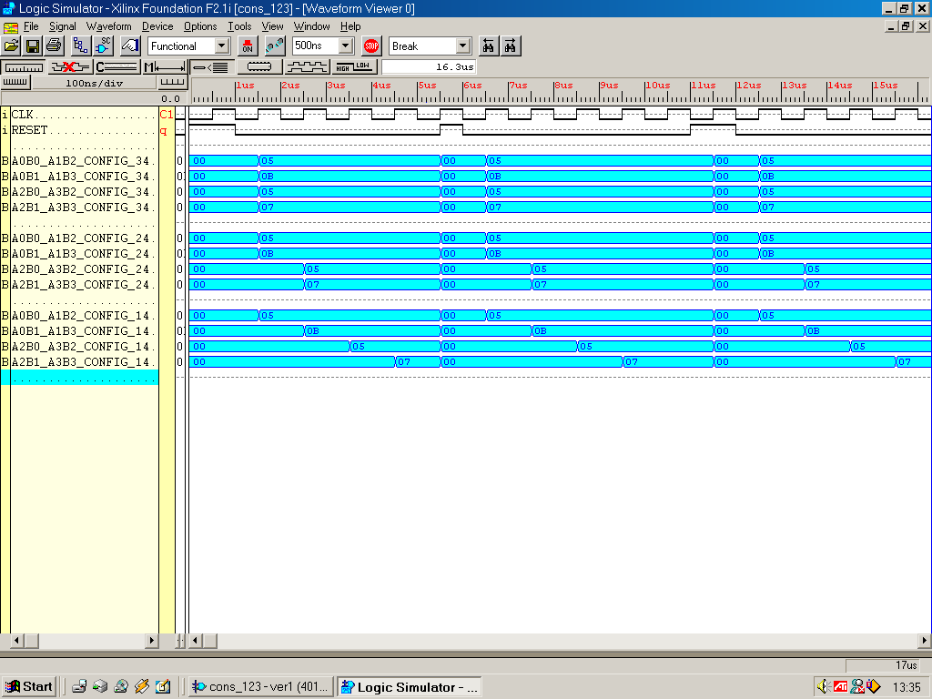
FIGURE 3-6 Simulation results achieved by ENTITY Systems_123

The results are shown above in blue. Configuration_3 results are shown in the four uppermost blue bands, Configuration_2 results are shown in the middle set of bands and Configuration_1's results are shown in the bottom blue band. The system must always be initially RESET to initialise the current state. These results clearly show the advantage of having a parallel architecture. Configuration_1, Configuration_2 & Configuration_3 completed the matrix multiplication in 4, 2 & 1 clock tick(s) respectively.
The next step after the process of design, synthesis and simulation is implementation. The target hardware for the design is a Xilinx XC4010XL PC84 FPGA. Using the Xilinx Foundation Series 2.1i software, the implement process (shown in Figure B) was undertaken, mapping the logic gates and interconnections into the FPGA. However the ENTITY Configurations_123 could not be placed and routed because all the external IOB’s were used up (not enough pins available). One solution would be to accumulate the separate configurations into one ASM controller, DSP and Data_Store that can be set up to perform the operation of the separate configurations.
The whole system operated correctly in simulation, but could not fit onto the target FPGA due to the masses of large buses required by the system. If the system was integrated, with an emphasis on bus re-use, could the system be built efficiently to give the correct results?

CHAPTER 4 Configurations Integrated – Design and Implementation

Design Thoughts

ASM Controller - Integrate the three FSM controllers of Configurations 1,2 & 3 into one Architecture. Only one configuration would be able operate at any one instant. Hence the amount of states required to control the DSP would have the accumulative amount of states of the three individual configurations.

Data_Store (Memory Block) - The memory elements would be integrated into one large ROM. Within the ROM, different processes would activate dependant the Configuration selected.

DSP - The amount of multipliers and adders would be kept to the same amount used for Configuration_3, this would allow all the configurations to process data in a parallel nature, valuable extra buses would be saved.

Answer_Store – would need to operate (in total) 7 different ways to account again for the separate configurations. 20 memory elements would be made available. The answer could be stored using 20 memory elements in 1 pass (emulating Configuration_3). The answer could be stored using two sets of 10 memory elements in 2 pass (emulating Configuration_2). Finally, the answer could be stored using four sets of 5 memory elements in 4 pass (emulating Configuration_1). The mode of storage would be dependant on what Configuration mode is selected. The required select signal needs to be 3 bits wide to cater for these seven operations. With these thoughts in mind the initial integrated configurations could now be visualised.

Test Data – As mentioned for Configurations 1, 2 & 3, the system would need to process the matrix multiplication for two 2x2 matrices. The values of the individual elements are hardwired in the Data_Store entity.

During this period, to give the VHDL script a more accessible layout, a package was produced. The package allowed easier recognition of VHDL data types, such as size of buses, which at a glance would not be recognisable. The finalised package can be viewed at the back of this report.
ON A 20-BIT BUS WHICH ENTERS THE ANSWER STORAGE

DATA SELECT SIGNAL
Integer range (6 downto 0)
MEMORY SELECT
SIGNAL 3-BITS WIDE
Matrix A
Data Element
Matrix B
Data Element
Matrix B
Data Element
Matrix A
Data Element
Matrix A
Data Element
Matrix B
Data Element
Matrix A
Data Element
Matrix B
Data Element
Matrix A
Data Element
Matrix B
Data Element
Matrix A
Data Element
Matrix B
Data Element
Matrix A
Data Element
Matrix B
Data Element
Matrix B
Data Element
Matrix A
Data Element
A(2)xB(1) + A(3)xB(3)
A(2)xB(0) + A(3)xB(2)
A(0)xB(1) + A(1)xB(3)
A(0)xB(0) + A(1)xB(2)
32-BIT
Elemental Data Bus
2-BIT
MUL

4-BIT
ADDER

ANSWER
STORE
STORES FOUR SETS OF SUM-OF PRODUCTS
FOUR 5-BIT DATA BUSES HOLD SOP. THIS DATA IS THEN PLACED

FSM CONTROLLER

4-BIT
ADDER

2-BIT
MUL

2-BIT
MUL

2-BIT
MUL

2-BIT
MUL

2-BIT
MUL

2-BIT
MUL

2-BIT
MUL

EIGHT 4-BIT DATA BUSES
4-BIT
ADDER

4-BIT
ADDER

DATA
STORE
ALLOCATE DATA TO MEMORY LOCATION
1, 2, 3 OR 4
S 3bits
Configuration Mode Select
FIGURE 4-1 High Level Abstraction of the Configuration Integrated System

The hardwired matrices data values are shown below. As mentioned before this data would be stored in the Data_Store in binary form ready for selection for the DSP.

2
1
0
1
1
2
1
0

MATRIX A MATRIX B

The multiplication and addition operations to be performed by the DSP of the system would be:-
3
1
4
0
(2 x 1) + (1 x 1) = 2 + 1 = 3
(2 x 2) + (1 x 0) = 4 + 0 = 4
(0 x 1) + (1 x 1) = 0 + 1 = 1
(0 x 2) + (1 x 0) = 0 + 0 = 0
MATRIX PRODUCT

4.1 Configurations_Integrated Testing

The behaviour model of ENTITY Cons_Integrate can be viewed on the supplied disk.

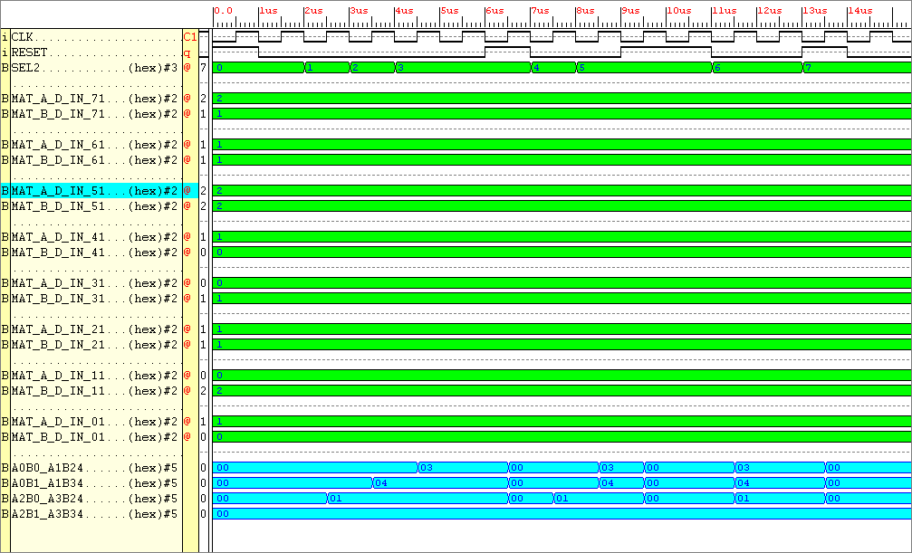
FIGURE 4-2 Simulation results for the Entity Whole System

Observe the results at the bottom of the figure in blue (these were the outputs from the DSP). The matrix product calculated above correlate exactly with the simulation results in Figure 4.2. The results spanned over seven states. In mode “Configuration_1” outputting the matrix product took 4 cycles, whilst the faster “Configuration 3” took only one cycle to complete the same multiplication. Each configuration’s results were separated by a RESET, without a zeroing of the output signals, the calculated values on the outputs would not be viewable.
Using the Xilinx Foundation 2.1i Series Software, the design could now be implemented. The FPGA place and routing software, without error, produced files which contained all the data required to program the FPGA. By using the program Floor planner available within the Xilinx Foundation suite, the structure of the design within the FPGA could now be viewed.

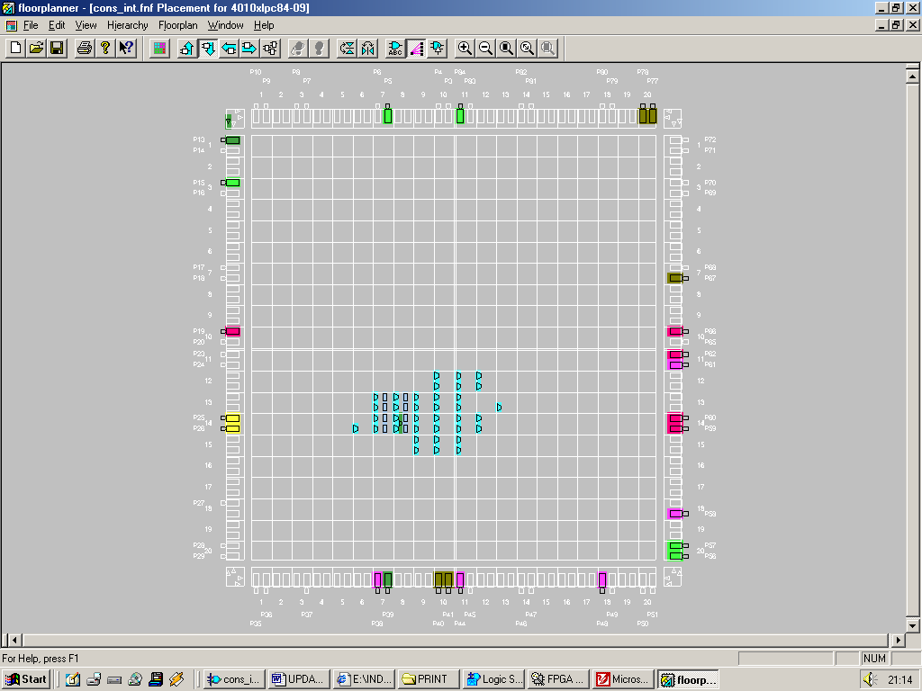
FIGURE 4-3 Design structure of the integrated Configurations within the FPGA

The floor plan view of the design shows it could be clearly routed and programmed in the FPGA. Now that that this simple system works (simulates and could be placed and routed) a few things could now be done to increase the complexity of the design. The format “the maximum magnitude of a matrix element as being 3” would be left in tact, but the size of the matrices could be upped. The ENTITY DATA_STORE would need to include more data, the multipliers and adders could be kept in tact ENTITY ANSWER_STORE would need to be more complex in order to store more data, also the ASM_CONTROLLER would require more states and steering logic. Using this design as a base to work from, the complexity of the system would be increased to handle larger matrices.

CHAPTER 5 Project 4X4 - Design

At the end of the day this system would be used to process matrix data, in this case 4x4 matrices. Shown below is an example of data required to be tested on the completed system.
2
3
3
1
1
2
1
3
2
1
2
1
2
2
2
1
2
1
3
1
1
2
2
3
1
2
1
3
3
1
0
2

MATRIX_A MATRIX_B
Shown below is the full set of hand calculations required to generate the matrix product of two 4x4 matrices.
(2 x 1) + (3 x 1) + (2 x 1) + (1 x 1) = 8
(3 x 1) + (1 x 1) + (2 x 1) + (1 x 1) = 7
(2 x 1) + (2 x 1) + (2 x 1) + (1 x 1) = 7
(2 x 1) + (1 x 1) + (3 x 1) + (1 x 1) = 7

(2 x 2) + (3 x 3) + (2 x 2) + (1 x 3) = 20
(3 x 2) + (1 x 3) + (2 x 2) + (1 x 3) = 16
(2 x 2) + (2 x 3) + (2 x 2) + (1 x 3) = 17
(2 x 2) + (1 x 3) + (3 x 2) + (1 x 3) = 16

(2 x 1) + (3 x 2) + (2 x 3) + (1 x 0) = 14
(3 x 1) + (1 x 2) + (2 x 3) + (1 x 0) = 11
(2 x 1) + (2 x 2) + (2 x 3) + (1 x 0) = 12
(2 x 1) + (1 x 2) + (3 x 3) + (1 x 0) = 13

(2 x 2) + (3 x 3) + (2 x 1) + (1 x 2) = 17
(3 x 2) + (1 x 3) + (2 x 1) + (1 x 2) = 13
(2 x 2) + (2 x 3) + (2 x 1) + (1 x 2) = 14
(2 x 2) + (1 x 3) + (3 x 1) + (1 x 2) = 12

Mentioned below is a summary of the problems encountered by this system through use of different evaluation methods.
The system was far too big for generous evaluation. The DSP itself had far too many Inputs/outputs to test. This device would require a total of 96 outputs, that is 96 pins, the FPGA only had 65 free. Excluding the clk, reset, mode select pins, the number of pins available were:-
CLK = 1 BIT
RESET = 1 BIT
MODE SELECT = 3 to 6 BITS
OUTPUT = (65 – 8) = 57

From the implementation reports 290 complex logic blocks out of the total 400 are used in the DSP of the 4x4 matrix multiplier. With the remaining 110 CLB’s, the FSM needs to be constructed. This is a good amount to work with, however there was a lot of data manipulation required by the finite state machine in order to create the matrix product.
A good way to output the data would be to have 34 seven segment displays placed onto a PCB (32 including the two seven segment displays which would be used to output the processing speed of the system). Each seven segment display would require at a minimum an 8-bit flip flop. The flip flop would be used store the answer in each element. The finished output system would comprise of a board with 34 seven segment displays plus 34 flip flops. This board would need to be designed using the PCB design program Areslite. To output the matrix product from the FPGA to the seven segment displays in one cycle would require 16 x 7 segment displays = 112 pins. This is not viable, however outputting the data for two seven segment displays is, requiring only 14 output pins. However 17 enable signals would be required in order to select the correct set of seven segment displays. Hence a total of 31 output pins would be required out of the 57 available, this hasn’t taken into consideration data inputting to the system.
An idea was to use the vacant external SRAM chip available on the XS40 board, this had an 8-bit output. It would require eight clock cycles to get 64-bits of data onto the Elemental data bus. However the process required to do was far from simple, using the RAM chip also rules out use of a number of pins available on the FPGA, every pin was vital . To store data in the SRAM knowledge of Intel Hex was needed, and the procedure to insert the data into RAM was cumbersome. Another method of inputting data would need to be considered.
After some serious thought, the system was ruled unviable. The 4x4 matrix system required too many FPGA complex logic blocks which were simply not available. Testing and verifying data by hand was becoming too cumbersome. The output matrix PCB display would be far too large (as shown in Figure 5-1).

Matrix display, 34 seven segment displays
INPUTS
1
1
1
1
1
2
2
2
3
1
1
3
0
1
1
2
1
1
1
0
2
1
0
0
1
3
3
3
0
1
1
1
0
1

Figure 5-1 Mock up layout of the 4x4 matrix multiplier display board

After ruling out the requirement for a 4x4 matrix multiplier what are the other options?

CHAPTER 6 3x3 Matrix Project - Design and Implementation

A simpler system would need to be developed and created to that previous, a system that would produce the product of two matrices up to the size of 3 rows by 3 columns.

But which multiplying operations could this system perform?

Matrix_A will multiply happily with Matrix_B IF the number of columns in Matrix_A equals the number of rows in Matrix_B. The following matrix multiplications have been chosen from those which are available, for input matrices with dimensions up to a size of 3 rows by 3 columns.
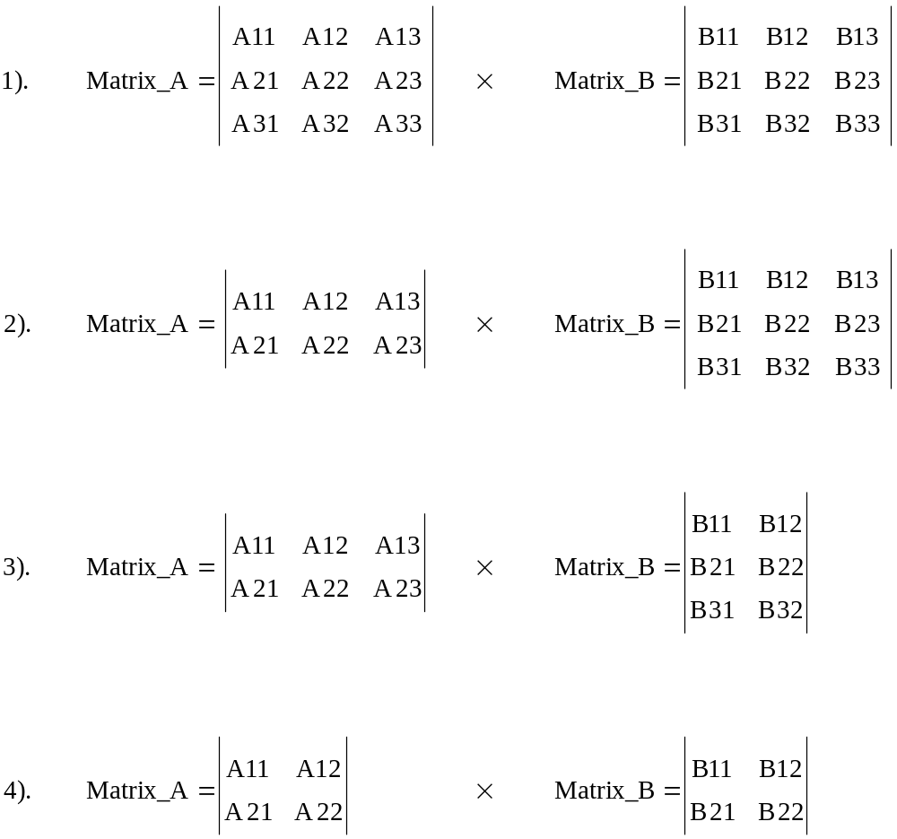

Hence the system would be required to handle 4 matrix multiplications.
Producing the DSP that calculates the matrix products would be a simple task. The DSP for the 4x4 matrix multiplier was developed previous, a scaled down version of this was all that was needed.

How’s the processing power of the system going to be measured?

A mechanism would be required that would allow the processing power of the serial and parallel architectures to be analysed. The most simple and one that came to mind almost immediately was the idea of using a counter to calculate the clock cycles required to process the matrix data. The counter would be required to count upto 18, 18 referring to the number of elements to be processed, when two 3x3 matrices are multiplied together using serial data processing. Converting decimal 18 into binary requires 5-bits, hence the output bus of the counter must be 5-bits wide. The counter must be resetable to handle multiple processing calculations. An enable input would be required to instruct the counter when to start incrementing, and to hold its output at a constant value.

How would one operate the System?

For the system to work effectively, it would need to be informed on the size of the matrices to be input. The system has been constrained to allow only four matrix multiplications (as shown on Page 31). The system can operate on the incoming (integer based) data serially or in parallel. So to inform the system of these two issues would require 8 different levels of input signal. 4 matrix multiplication modes, each to be either processed serially or in parallel. Three external switches (information 3-bits wide) would allow the eight different modes of operation. The
most significant bit signifies to the system, perform either a serial (0) or a parallel (1) matrix multiplication.
The two least significant bits indicate to the system what size matrices will be encountered (as shown below):-

000 = 0 = Serial Matrix Multiplication, (2x2) by a (2x2)
100 = 4 = Parallel Matrix Multiplication, (2x2) by a (2x2)

001 = 1 = Serial Matrix Multiplication, (2x3) by a (3x2)
101 = 5 = Parallel Matrix Multiplication, (2x3) by a (3x2)

010 = 2 = Serial Matrix Multiplication, (2x3) by a (3x3)
110 = 6 = Parallel Matrix Multiplication, (2x3) by a (3x3)

011 = 3 = Serial Matrix Multiplication, (3x3) by a (3x3)
111 = 7 = Parallel Matrix Multiplication, (3x3) by a (3x3)

Once the system knows what size matrices are entering the system, and in what manner to process the data (serially or in parallel), the matrix data can then be input to the system in binary format. The matrix product data would then be output to a display board.

To get an idea of what the DSP was required to achieve, a standard 3x3 matrix multiplication was evaluated. From the findings and through further research into matrix algorithms, a more efficient matrix multiplier could be designed.

A13
A23
A11
A12
A21
A22
A31
A32
A33
B13
B23
B11
B12
B21
B22
B31
B32
B33
P13
P23
P11
P12
P21
P22
P31
P32
P33
=
x

MATRIX_A MATRIX_B PRODUCT_MATRIX

(A11 x B11) + (A12 x B21) + (A13 x B31) = P₁₁
(A21 x B11) + (A22 x B21) + (A23 x B31) = P₂₁
(A31 x B11) + (A32 x B21) + (A33 x B31) = P₃₁

(A11 x B12) + (A12 x B22) + (A13 x B32) = P₁₂
(A21 x B12) + (A22 x B22) + (A23 x B32) = P₂₂
(A31 x B12) + (A32 x B22) + (A33 x B32) = P₃₂

(A11 x B13) + (A12 x B23) + (A13 x B33) = P₁₃
(A21 x B13) + (A22 x B23) + (A23 x B33) = P₂₃
(A31 x B13) + (A32 x B23) + (A33 x B33) = P₃₃

By looking at the methodology involved for solving a 3 x 3 matrix it can be seen that 27 multiplications are involved. Also for every 3 multiplication operations 1 addition is required.

NUMBER OF MULTIPLIERS REQUIRED = 27
NUMBER OF ADDERS REQUIRED = 9

There are 18 elements involved in a 3x3 by a 3x3 matrix multiplication, each element as stated before would be limited to a 2-bit value, hence:-

BITS OF INPUT DATA = (No. of elements in MATRIX_A + No. of elements in
MATRIX_B) x (Bit width magnitude of a elements data)

BITS OF INPUT DATA = ((3x3 )+ (3x3)) x 2 = 36 bits

If all the elements had a magnitude of 3 (largest case) then the magnitude of an element of the product matrix would be

(A11 x B11) + (A12 x B21) + (A13 x B31)
(3 x 3) + (3 x 3) + (3 x 3)
9 + 9 + 9 = 27,
Convert decimal 27 to binary = 11011, which is 5-bits wide

The output of the system would need to cater for 5-bit wide data (largest case), but there are 9 products (as shown on page 32), hence:-

BITS OF OUTPUT DATA = (No. of elemental products) x (bit width of largest case
binary answer)

BITS OF OUTPUT DATA = 9 x 5 = 45-bits

In the previous Configurations_ Integrated system, data was stored in the system in a block of ROM. This block of ROM could not be written to, the input data held once created could not be altered. To fulfil an aim, it would be allot more satisfying for the user to input his or her own matrices data. As explained earlier, this could be done by inputting data using the Windows based WinXSPort program through the parallel port cable into the XS40 board where the FPGA lies.

But how will the data be stored in the FPGA?

A digital entity which, as part of the DSP that would gather data external to the FPGA. Because 36-bits of input data would be required by the matrix multiplier, a total of 36 storage elements would also be required.

What type of storage element could one use?

By structuring the semantics of the behavioural VHDL text in a particular way, when synthesising the text, the synthesis tool (i.e. the compiler) would look at the syntax and create a particular storage element. Two types of storage elements are available on the FPGA, there are either latches or D-type flip-flops. The difference between them is, D-type flip-flops are updated on the edge transition of a signal, latches are updated in accordance with the level of a particular signal. The synthesis tool will create either D-type flip-flops or latches in accordance with the update mechanism specified. Initially latches were evaluated.

How will the answer from the system convert into that which can be read by the seven segment display?

The seven segment encoder is required to fetch and decode the processing count and the value of each element of the 3x3 answer product matrix in turn.

6.1 Entity Data_Store

This entity is a means of storing data, entering externally to the FPGA from the WinXSport program. The entity contains 36 latches, the WinXSport program can input a maximum of 8-bits of data at a time to this entity. To be sure the data would be sent in a controlled manner, a clock signal would need to be used as one of these inputs. It was decided that data would be sent to the Data_Store entity in 6-bit chunks. Hence 6 data cycles would be required to send all the matrix data. Data could’ve been input in 7-bit chunks, which would also require 6 clock cycles, but the 36-bits of matrix data would not be divided up evenly.

- 1-bit external clock signal
- 6-bits of data

The entity Data_Store would be asked to store 6-bits of data at a time in accordance with the high level of the clock input. Every high clock level, the Data_Store would increase the value of an internal signal (a clock edge counter) up to a maximum value of 6. This internal signal would be used to select each set of 6 latches, until all 36 latches have been selected and data input to them. To reset all the latches, an external input, when high would take precedence over any input signal and ensure the data on the Data_Store output remains at logic ‘0’. This input would not be used in conjunction with the WinXSport program.

Problem From simulating the initial Data_Store (VHDL script withheld from
the report) the output of latches refuse to reset.

Solution Use D-type flip-flops

By altering the behavioural VHDL script, 36 D-type flip-flops would now be involved in the data transfer, if the rising edge of the clock signal occurred, dependant on the select signal, 6-bits of input data would be transferred to the output of 6 flip-flops. The Data Store algorithm would now be created which will allowed (stable) resetable flip flops to be used in place of the unresetable (unstable) latches.
For the matrix multiplier to operate, all input matrix data must be ready. Once all the data has been collected, a one bit output from the ENTITY Data_Store to the FSM would be required, that flags to the system “ready to start computing,” this signal would be called Start_Com.

6.1.1 Data_Store Testing

The behaviour model of ENTITY Data_Store can be viewed on the supplied disk.

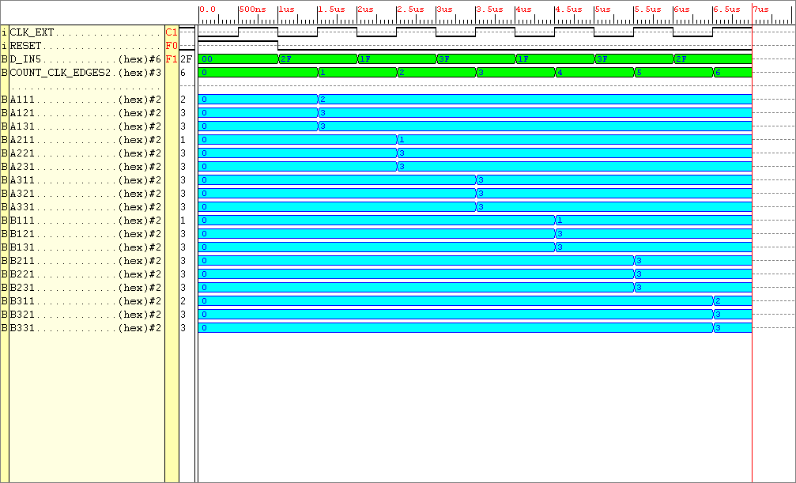
FIGURE 6-1 Simulation results for the new edge triggered Entity Data_Store

Looking at Figure 6-1 it can be seen that when RESET is high, the output of Data_Store goes low. When RESET is low, the input data is seen on every rising edge of the clock. In accordance with the select signal “COUNT_CLK_EDGES”, 6-bits of data is sent to a group of 3 outputs. To store all 18 elements of data requires 6 clock cycles.

There were 2 WARNINGS inferred when implementing (software place and routing) the synthesised model on the Xilinx Foundation 2.1 software. After visiting the Xilinx website it was clear that these warnings were caused by a software fault. However the system behaved correctly.
The implementation report indicated that this entity only required 6 complex logic blocks, there are 400 available on the FPGA, hence this would be a very small part of the overall system.
The output of the Entity Data_Store would be input to the matrix multiplier. The matrix multiplier is made up of a row of parallel multipliers, followed by a row of parallel adders. This system allows the products to be produced (output of the adders), then the product of sums to be produced (the completed matrix product). Hence the first arithmetic block the matrices data would meet, would be the parallel multipliers. The entity used to multiply two 3x3 matrices would require 27 two input (each input would be 2bits wide) multipliers (as discussed on page 32). When dealing with high level arithmetic logic on integer based numbers, the VHDL program was required to know what type of integers they will be i.e. either signed (negative or positive) or unsigned (the sign of the number is not an issue). The system handles unsigned, integer based matrix data. In order to output data from the Entity Data_Store of type unsigned, the input data must also be of the unsigned data type.

6.2 Inter Store

An entity would be needed in-between entities Data_Store and Multipliers. This entity would be used to store and select the input data in accordance with the finite state machine mode select signals. Hence when serial mode is selected the data from this entity called “Inter_Store” outputs the element coefficients one at a time, hence in the worst case 18 clock cycles will be required to achieve the answer serially for two 3x3 matrix multiplications.
For the entity Inter_Store to operate 18 select signals were required. To represent 18 in binary requires five binary digits. Hence this entity requires a CLK, RESET, 36-bit inputs, a 5-bit select and a 36-bit output.
This is a description of how this ENTITY works, the brains are used in the selection of data. If parallel mode is selected, all data will be outputted from the entity in parallel. If serial mode is selected, then dependant on the matrices size selected, data will be outputted from the device in a serial nature. If the matrices in question are of a small size, then less clock cycles are required to pass all of it’s data onto the arithmetic logic.

6.2.1 Inter Store Testing

The behaviour model of Entity Inter_Store can be viewed on the supplied disk.

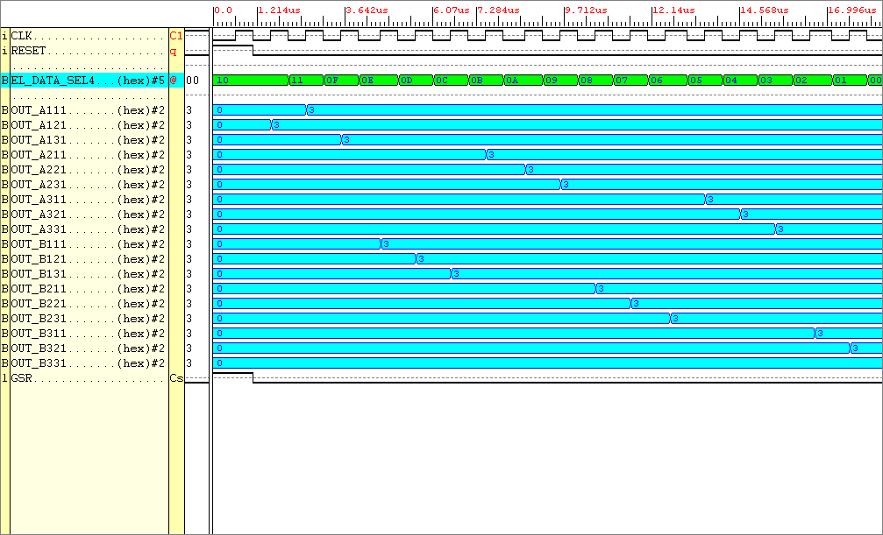
FIGURE 6-2 Simulation results for the Entity INTER_STORE

Looking at Figure 6-2. RESET has precedence over all other input signals, when high zeros the outputs. All the input signals are not shown but there are 18 of them, when the DATA_SEL signal is in the range 0 to 17, when the rising edge of the clock occurs, one of the inputs is outputted. When DATA_SEL(18) is chosen all the data is outputted on the rising edge of the clock, in one instance. Knowing the entity performed true to it’s design it was then placed and routed using the Xilinx Foundation 2.1i Software. This allowed further analysis such as FPGA routing constraints, and physical size determination. The Inter_Store entity required 63 complex logic blocks.

6.3 Entity Multipliers

The entity used to multiply two 3x3 matrices would require 27 two input (2bit) multipliers (as discussed on page 32). With each multiplier assigned it’s own unique combination of the input matrices elements. Lower order matrices can be multiplied together using this same architecture, however some of the multipliers would be redundant.

6.3.1 Multiplier Testing

The behaviour model of ENTITY Multipliers can be viewed on the supplied disk.

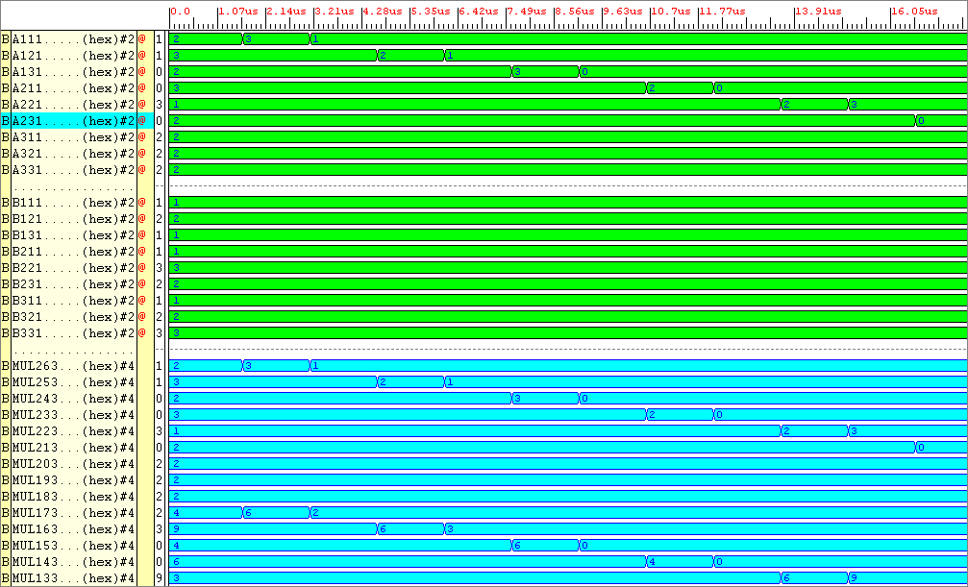
FIGURE 6-3 Simulation Results for the entity Multipliers

The A and B inputs (shown as a green waveform) are indexed from 11 to 33. For example, A11 refers to Matrix A, element position row 1, column 1, B33 refers to Matrix B, element position row 3, column 3. The output waveform (shown in blue) ranged from Mul0 to Mul26, (there are 27 multiplications involved in a 3x3 matrix product answer) Mul26 refers to the very first product A11 x B11 (Mul0 is the last, but is not shown). Page 35 shows the other 26 multiplications needed to produce the products ready for the adder section of the DSP to sum. The Matrix B element coefficients were kept constant (at a value in the range 0 to 3) whilst the Matrix A values were altered. The answers achieved by the entity were correct. Knowing the entity performed true to it’s design it was then placed and routed using the Xilinx Foundation 2.1i Software. This allowed further analysis such as FPGA routing constraints, and physical size determination. The multiplier entity required 54 complex logic blocks.

6.4 Entity Adders

The adder entity required 9 adders which consist of 3, 4bit inputs and 9, 5bit outputs. This would allow all the products produced by the multiplier entity to be summed resulting in the matrix product. A very high level behavioural adder model was used. To allow two 4-bit numbers to be added together to produce a 5-bit answer, the VHDL concatenation operator was required. The concatenation operator was a means of converting the 4-bit numbers into ones of 5-bits, allowing a synthesized model to be produced.

6.4.1 Adders Testing

The behaviour model of Entity Adders can be viewed on the supplied disk.
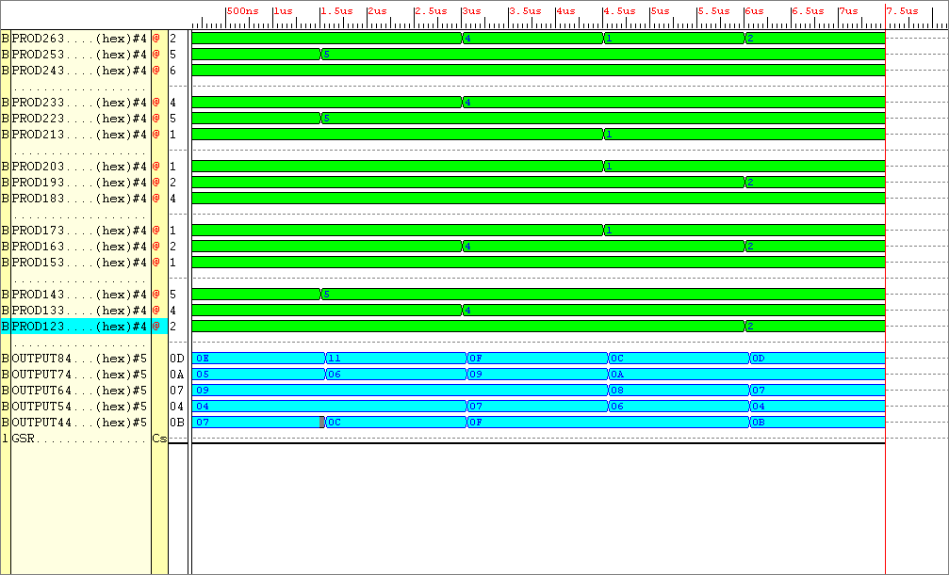
FIGURE 6-4 Simulation results from ENTITY Adders

The simulation results of Figure 6-4 can easily be evaluated. Not all the inputs and outputs are shown here. The additions required are divided into groups of three, OUTPUT8 corresponds to the sum of the first set of three numbers, OUTPUT7 corresponds to the output of the second set of sums and so on. The outputs shown in blue at the bottom of the simulation results are in hexadecimal format. The first three additions at inputs PROD 26 downto 24 produced the answer “0E” at Output8, which corresponds to a decimal value of 14. Knowing the entity performed true to it’s design it was then placed and routed using the Xilinx Foundation 2.1i Software. This allowed further analysis such as FPGA routing constraints, and physical size determination. The adder entity required 51 complex logic blocks.

6.5 Entity Counter

In the VHDL text a variable assignment had been made to increment the count as opposed to a signal assignment. This allowed the count to be held when the enable signal is low, otherwise the count would’ve been initialised.

6.5.1 Counter Testing

The behaviour model of Entity Counter can be viewed on the supplied disk.
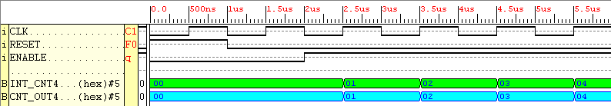
FIGURE 6-5 Simulation results gathered from the synthesised entity Counter

Looking at Figure 6-5, the behaviour of the system can be clearly seen. When RESET is high the output of the system goes low. When signal RESET is low, if EN is low the internal variable is never seen on the output. When both RESET is low and EN is high, the internal variable(shown in green) is increased on every rising edge of the clock, and is seen by the system the output (shown in blue). Knowing the entity performed true to it’s design it was then placed and routed using the Xilinx Foundation Software. This allowed further analysis such as FPGA routing constraints, and physical size determination. The Counter entity required 4 complex logic blocks.

6.6 Entity Answer Store

This entity is a means of storing the answer in raw binary format, hence it outputs what’s on it’s inputs on the clock edge, when enabled.

6.6.1 Answer Store Testing

The behaviour model of Entity Answer_Store can be viewed on the supplied disk.

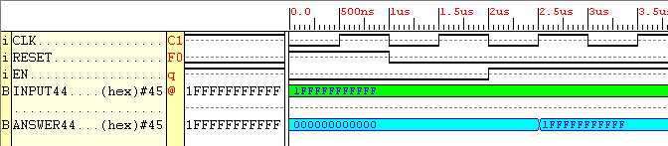
FIGURE 6-6 Simulation results taken from entity Answer_Store

Looking at Figure 6-6, the behaviour of the system can be clearly seen. When RESET is high the output of the system goes low. When signal RESET is low, if EN is low the input is never seen on the output. When both RESET is low and EN is high, the input (shown in green) is seen by the system the output (shown in blue), and is updated on every rising edge of the clock. Knowing the entity performed true to it’s design it was then placed and routed using the Xilinx Foundation 2.1i Software. This allowed further analysis such as FPGA routing constraints, and physical size determination. The adders entity required 23 complex logic blocks.

6.7 Entity Seven Segment Encoder

The seven segment encoder is purely combinational logic. The matrix product answer, and processing count from the counter are input to this entity. The largest matrix product to be outputted is one which has 3 rows and 3 columns, 9 elements. To allow selection of the nine different elements and the processing count, a 4bit wide select line was required. Dependant on the value of the select signal, a product element is decoded into a 14-bit binary value ready to be sent to two seven segment displays.

6.7.1 Seven Segment Encoder Testing

The behaviour model of Entity Seven_Seg_Enc can be viewed on the supplied disk.

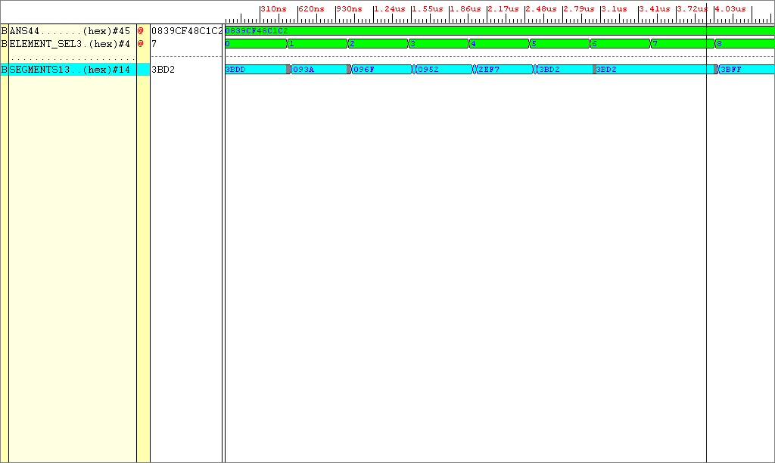
FIGURE 6-7 Simulation Results from ENTITY Seven_Seg_Enc

The test pattern shown as applied to the input ANS was 8 7 7 7 20 17 16 14 2, each of these integers are represented by a binary value, five bits wide. Each number represents an element of a standard product matrix, for example the last product element “2” will be bit extended to “00010”.

Decimal test pattern data 8 7 7 7 20 17 16 14 2
Binary (5bit) conversion 01000 00111 00111 00111 10100 10001 10000 01110 00010
Group for Hex conversion 0.1000.0011.1001.1100.1111.0100.1000.1100.0001.1100.0010
Hexadecimal conversion 0839CF48C1C2

The test pattern is then converted to hexadecimal equivalent. The result is shown on the simulation input as 0839CF48C1C2. Dependant on the ELEMENT_SEL value (10 selections, 4bit select signal), 1 of the 10 segment values will be outputted in seven segment display encoding. The output in blue refers to the hexadecimal value (a 14bit binary value) required to stimulate two seven segment displays. Knowing the entity performed true to it’s design it was then placed and routed using the Xilinx Foundation Software. This allowed further analysis such as FPGA routing constraints, and physical size determination. The Seven_Seg_Enc entity required 95 complex logic blocks.

6.8 The Finite State Machine

In order to signify to the finite state machine “data has now been loaded into the data store entity now act upon it,” there must be a signal between these two entities in order to communicate this information. A one bit output from the ENTITY Data_Store to the FSM was used to flags “ready to start computing,” this signal being called Start_Com.
The finite state machine is split into three types of states, serial states, parallel states and output states. During the parallel matrix multiplicative process each of the four available matrix multiplications are handled in the same fashion. The finite machine will enter the parallel states allowing the DSP to receive matrix data and compute the matrix multiplication. The output states follow the parallel states and are used to select the elements of the matrix product to be input to the seven segment displays. There are many more serial processing states than parallel ones, this is due to the state machine needing to select one element of the input matrices at a time, and there are four matrix multiplications available. The output state sequence will be the same for parallel and serial processes.

6.8.1 Finite State Machine Testing

The behaviour model of Entity Finite_State_Machine can be viewed on the supplied disk.

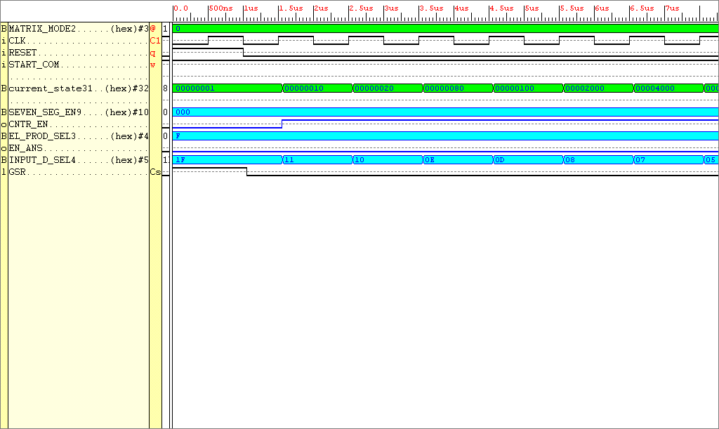
FIGURE 6-8 Simulation test results for entity Config_Inf

The operation of the finite state machine is complex, a small cross-section of results are shown in Figure 6-8. When RESET is high all outputs fall to logic zero. The input signal START_COM acts as an enable, when high it enables the system to go through it’s state transitions. The finite state machine inputs outputs the appropriate enabling signals to the DSP in accordance with the matrix mode. In this particular example the select signals indicate serial data processing. When the START_COM signal is received the counter immediately counts the amount of clock cycles required to process the data. While the counter ticks away, different elements of the input matrices are being selected using output signal INPUT_D_SEL. What isn’t shown here (for clarity purposes) is what happens when all the data is processed. At that point the EN_ANS signal is outputted that allows the answer matrix to be stored. Each element of the product matrix is selected by the output signal EL_PROD_SEL to be encoded and outputted. Knowing the entity performed true to it’s design it was then placed and routed using the Xilinx Foundation Software. This allowed further analysis such as FPGA routing constraints, and physical size determination. The Finite State Machine entity required 44 complex logic blocks.

6.9 Entity Config Inf

A simple explanation for this entity is as follows:

- If Reset is high output an ‘R’ to the XS40 board the seven segment display
- Else if Start Com is high output a ‘C’ on the seven segment display
- Else look at the value on the Matrix Mode and output that value to the seven segment display

6.9.1 Config Inf Testing

The behaviour model of Entity Config_Inf can be viewed on the supplied disk.
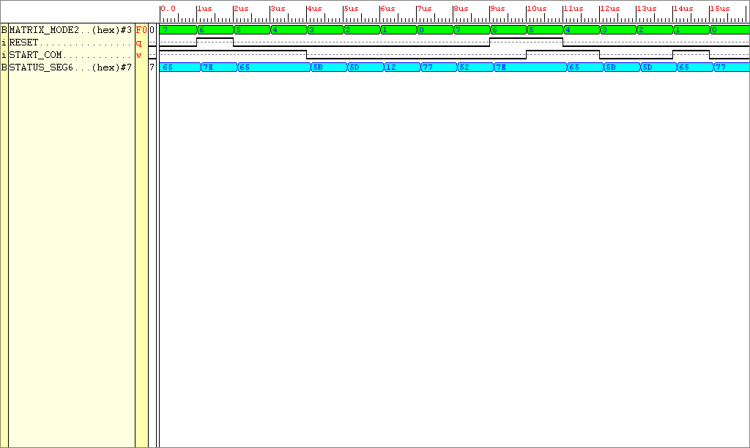

Figure 6-9 Simulation results taken from the Xilinx Foundation Verification Tool for the entity Config_Inf

The description given in Chapter 6.9 can be looked at, at a lower level. Figure 6-9 shows that when RESET is high the system outputs R i.e. The output hexadecimal code for RESET is 7E. Else if START_COM is high the system outputs hexadecimal code 65 “C”. If neither RESET or START_COM are high the MATRIX is read.Great, this entity will give information regarding how the system is configured and if the starting flag is being sent to the finite state machine. Knowing the entity performed true to it’s design it was then placed and routed using the Xilinx Foundation Software. This allowed further analysis such as FPGA routing constraints, and physical size determination. The Finite State Machine entity required 44 complex logic blocks.

The total number of CLB’s required for the system in total is

Data_Store : 6 CLB’s
Inter_Store : 63 CLB’s
Multiplier : 54 CLB’s
Adder : 54 CLB’s
Answer_Store : 23 CLB’s
Counter : 4 CLB’s
Seven_Seg_En : 95 CLB’s
Config Inf : 3 CLB’s
Finite State Machine : 44 CLB’s
_____________________________________
Total : 346 CLB’s

There are a total of 400 CLB’s available on the XC4010XL PC84 FPGA, the system fits comfortably in the available space. The high level design schematic for the complete system is shown in Figure 6-10.

STATUS SEGMENTS
(7-BITS)
SEVEN SEGMENT ENABLE (10-BITS)
CNTR_EN Signal (1-bit)

Counter
MATRIX MODE
(3-BITS)

FSM

CONFIG
INF
MATRIX MODE
(3-BITS)

CLK
RESET
RESET
RESET
CLK
CNT_OUT (5-bits)

START
COM
(1-bit)
INPUT EL SELECT
(5-bits)
OUTPUT EL SEL
(4-bits)
ANSWER STORE EN (1-bit)

Data Store

Multipliers

Adders

Answer Store

Seven Seg Enc

Inter
Store

EXTERNAL CLK and data
(7-bits)

SEGMENTS
(14-BITS)
RESET
CLK
RESET
CLK
Figure 6-10 High Level Abstraction of the Project 3x3 System
A means of externally selecting the matrix mode and resetting the system was given thought. This would be a simple task. To select the matrix mode 3 switches in a single package were needed, a 4bit dip switch was opted for (3bit dip switches were not available). The resetting of the system was emulated using a push button switch. Both sets of switches operated on 5V supply rails, when either was depressed, a 5V potential “logic ‘1’” would be sent to the FPGA. Both these switches were integrated onto a single PCB whose layout is present in the appendix of this report.

Another problem to overcome was data input, using the onboard RAM on the XS40 board was an option, but the procedure required to access it seemed too complex a task. A more user friendly way to input data lied within a program called WinXSport, part of the XSTOOLS (a program available for the XS40 board). This allowed a windows based simulation program to input data to the input of the FPGA through the parallel port in quantities up to eight-bits.
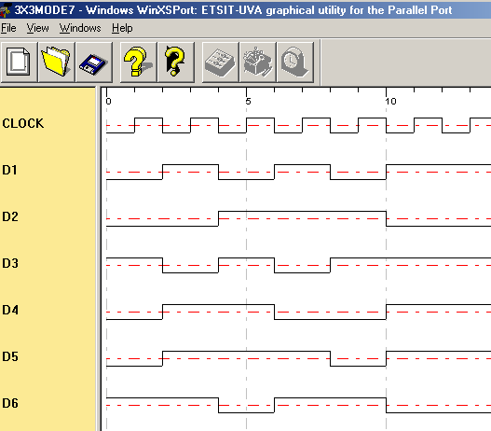

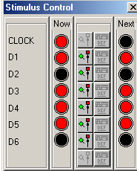

FIGURE 6-11 Screen capture from the XS40 simulation tool WinXSport showing clock and data signals

How would one input matrix data into the WinXSport program?

Take for example inputting two 2x2 matrices into the system. The two 2x2 matrices would be made to fit a template used for the multiplication of two matrices 3x3. The system caters for 4 different matrix multiplications up to that of two 3x3 multiplications. Logic zeros must be entered in the appropriate gaps (as shown below).

Matrix data is read, row by row, matrix A first, matrix B afterwards.
Each element is converted into it’s two bit binary equivalent. Hence 36-bits of information would be entered into the system (calculated later). The binary data would then be split into 6-bit segments, each set of six bits reversed then recorded on the WinXSport program.

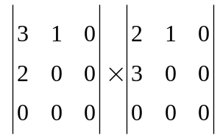

(2x2) by a (2x2) result is a 2x2

Decimal, 1 dimensional equivalent of the matrices data 310200000210300000

Bit stream, made up of two bit numbers
110100100000000000100100110000000000

Split the bit stream up into six bit segments starting with the LSB
110100 100000 000000 100100 110000 000000

Reverse each set of six bits, input into the XSport program
001011 000001 000000 001001 000011 000000

By what means will the matrix product answer and processing count be displayed?

To show the answer produced by this system, a number of options were available. Display the answer on the computer VDU by some means or use of a display board (PCB) with a number of seven segment displays arranged in a matrix fashion. The latter was chosen due to lack of facility in displaying information to the PC monitor. To output the matrix answer and the number of processing clock cycles to the seven segment displays would require many outputs (which the FPGA cannot afford). As analysed on Page 32, the maximum magnitude an element of the matrix product can be is 27. 27 is a two digit number, 2 seven segment displays would be required to display this number. Hence 18 seven segment displays are required to display the 3x3 matrix product plus 2 displays for the processing count (maximum processing count encountered is 18, 2-digits), maximum total displays required, 20. 20 seven segment displays alone require 280 (20 x 14) outputs. The FPGA has a maximum of 63 outputs available; a compromise must exist between FPGA outputs and number of seven segment displays outputted to. The matrix product would be outputted to 2 seven segment displays at a time. Hence 14 outputs from the FPGA are required in order to generate the matrix product for a particular segment. 10 clock cycles and 10 different select input signals would be required to output the full answer.

How does the seven segment display board work?

The seven segment display board was made up of 20 segments to display the product matrix and processing count. For each seven segment display, a storage element was required. An 8-bit (7-bit flip flops are not available) D-type flip-flop was used as this storage element to hold the values of each product element on the seven segment displays. The 8-bit flip-flops are made up of 10 inputs and 8 outputs. The 10 inputs consisted of a clock, a clear and 8 inputs to the 8 flip-flops. The outputs consisted of 8 outputs of the flip-flops. Looking at Figure X (the system layout diagram), the finite state machine has a 10-bit output called SEVEN_SEG_EN. These 10 outputs are used as enabling signals on all 10 pairs of seven segment displays i.e. Each of the SEVEN_SEG_EN were connected to the clock of a pair of flip flops. The system would send the data for a pair of seven segment displays. One of the 10 enable signals would go high, the clock input on the flip flops sees a rising edge, the data is clocked through. This process would occur 10 times in order to get both the matrix product and processing count outputted. The seven segment displays and flip flops were routed onto PCB, the templates for the PCB design’s are placed in Appendix C of this report.

To show the system worked before connecting the seven segment displays up to the XS40 board a device called the Pod-a-lyzer was used. The Pod-a-lyzer acquires data from the system when an event happens to the outputs of the system. In this case, when the signal START_COM goes high data is acquired at the speed of the clock. Shown below are the pod-a-lyzer results achieved by the finalised system.
The system outputs the product matrix, element by element, each element being made up of two digits. The binary data sent to each pair of seven segment displays is 14bits wide. The pod-a-lyzer results are in hexadecimal format, equivalent to the 14-bit binary code. The table below has two columns, the seven segment display code in hexadecimal format in the left column and the equivalent decimal number code in the right hand column.
Seven Segment Display Hex Code | Number Decimal
3FFF | 00
3B92 | 01
3BDD | 02
3BDB | 03
3BBA | 04
3BEB | 05
3BEF | 06
3BD2 | 07
3BFF | 08
3BFB | 09
0977 | 10
0912 | 11
095D | 12
095B | 13
093A | 14
096B | 15
096F | 16
0952 | 17
097F | 18
097B | 19
2EF7 | 20
2E92 | 21
---- | 22
---- | 23
2EBA | 24
---- | 25
---- | 26
2ED2 | 27

On the next page the results achieved by the final system are shown. These simulation results are screen shots taken from the Pod-a-lyzer probe program. For each of the available matrix multiplications, elemental data was selected, the product calculated by hand (calculations shown in Appendix B of this report), then compared against the simulation results achieved by the hardware.
MATRIX MULTIPLICATION, (2x2) BY A (2x2)



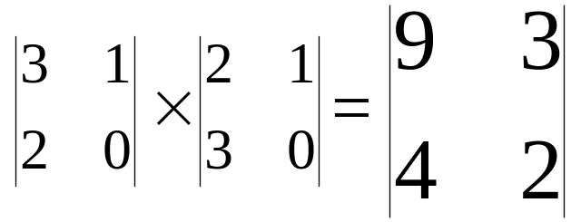
Matrix Mode 0 – Serial Processing
Matrix Mode 4 – Parallel Processing
Processing Count
(clock cycles)
8
01

MATRIX MULTIPLICATION, (2x3) BY A (3x2)
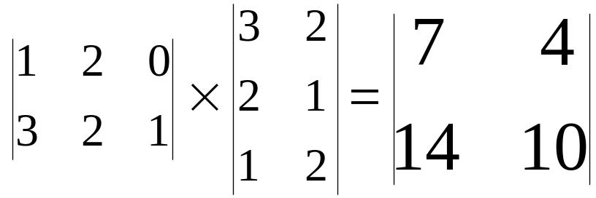


Matrix Mode 5 – Parallel Processing
Matrix Mode 1 – Serial Processing
Processing Count
(clock cycles)
01
12

MATRIX MULTIPLICATION, (2x3) BY A (3x3)
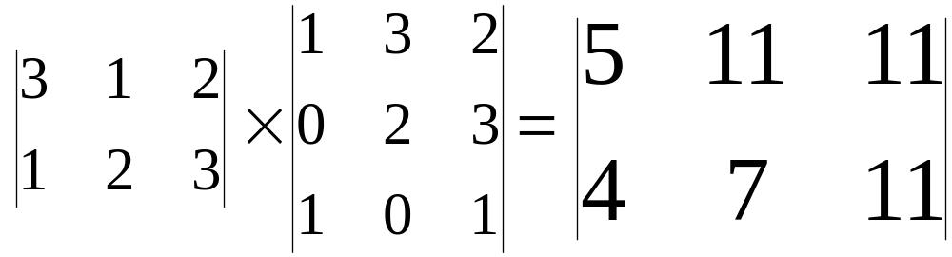


Matrix Mode 2 – Serial Data Processing
Matrix Mode 6 – Parallel Data Processing
01
15
Processing Count
(clock cycles)
Processing Count
(clock cycles)

MATRIX MULTIPLICATION, (3x3) BY A (3x3)
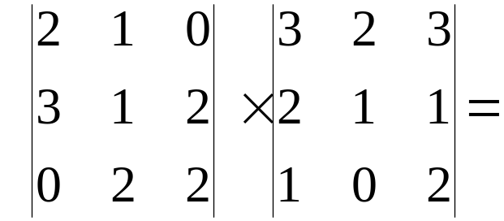


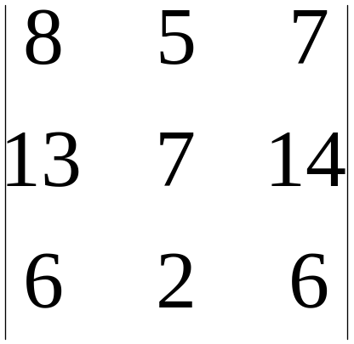
Matrix Mode 3 – Serial Data Processing
Matrix Mode 7 – Parallel Data Processing
18
Processing Count
(clock cycles)
01

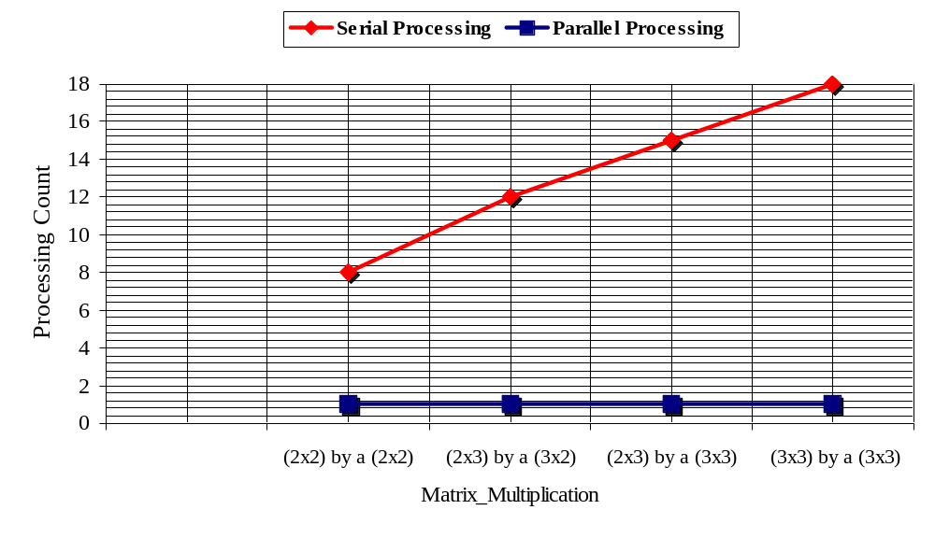The results shown above gives an overview of what the system achieved. The most notable piece of information in the simulation results is the processing count acquired for both the serial and parallel data processing systems. These results are plotted in the graph below.
Figure 6-12 A graph to show how the processing count of a aerial and parallel system changes with the size of the matrix multiplication

Looking at Figure 6-12, for a parallel system the processing count remains constant for all sizes of input matrices. When data is processed using the serial processor, the processing count increases proportionally with the size of the matrix multiplication. The system takes 10 clock cycles more to process two 3x3 matrices than it does to process two 2x2 matrices.

Seven Segment Display Fails to Operate –
The seven segment displays would not display the correct output. The display board required input signals at a potential of 5V. It could be seen that the potential at the FPGA outputs were not 5V. The potential at the FPGA pins varied from as little as 1.5V up to a maximum of 5V. The probable cause of this was the display board itself. The flip flops should have buffered the voltages appearing on it’s inputs. Because this was not the case, the display board was scraped, the pod-a-lyzer probe was used to show the system performing.
CHAPTER 7 3x3 Matrix Project – Evaluation

- Reliability of the end-product

The end-product wasn’t thoroughly test benched over long periods of time, only after long haul testing could one accurately say that the product was/was not reliable. There were 3 components that governed the reliability of the end-product, the external switches, the XS40 board and the pod-a-lyzer. The XS40 board is a commercial product, in it’s own right ‘tis predictably reliable. The external switches are simple, switch, 5V potential drop occurs across a resistor, siphon off positive potential. They were reliable unless the voltage supplied to them slipped below 5V (the operating voltage of the FPGA), the FPGA would not be able to distinguish a logic ‘1’ from a logic ‘0’. The pod-a-lyzer again is a commercial product, it operates again at the same potential as the switches and the FPGA. When correctly set up, under the pod-a-lyzer software package, the correct potential at the FPGA outputs would be displayed. In the short term, tests that were performed on the end-product gave reliable results.

- Usability of the end product

The finished product was one made not for commercial use, but a prototype ready for testing.
Without a detailed set of instructions one could not operate this device. The procedure required to operate the prototype device was very long winded, and is as follows:-

- Turn on power supply to the XS40 board, 5V dc power supply to power pod-a-lyzer and external switches, switch on computer.
- Launch three different software packages Xsload, WinXSport and the pod-a-lyzer program.
- Download bit file into the FPGA using Xsload.
- Initiate probe program, load input matrices to the FPGA using WinXSport program
- Observe probe results.

Methods for increasing the usability of the system are described in the proceeding pages.

  - To what extent have the specified objectives of the project been met?

The first objective was “to Investigate and develop a VHDL scripted algorithm which implements the matrix multiplier.” There were a small number of designs that tried to emulate the action of the matrix multiplier. Some design were over specified and way too complex for an amateur designer. The VHDL algorithm that was eventually finalised, implemented a matrix multiplier, it allowed the user to specify the matrices elements. The user was given the freedom of selecting one of four matrix multiplications. The objective was met and even extended to allow user configuration.
The second objective was “To investigate various architecture devices.” From the projects birth, high level matrix multipliers were used to lower the difficulty of the job at hand. Initially a single 2bit multiplier was created, then instantiated many times in a higher level entity to make up the multiplicative part of the matrix multiplier. In multiplier entities that proceeded it, the many multipliers were described behaviourally using ‘*’in a single high level entity. The 4bit adders were structurally constructed using low level logic, such as behaviourally models of AND, OR and XOR. The structural make up of such an adder was replaced by a behavioural one which used the high level arithmetic operator ‘+’. The operation of both the high level adders and multipliers were compared against adders and multipliers created using look up tables. It could be seen that the lookup table derivations took up a lot more real estate in the FPGA than the arithmetic operated entities, hence they were never implemented. The matrix multiplication was observed on paper , the addition and multiplication operations arranged to work concurrently and left in this form for following systems. In passing not many architectures were investigated, because the efficiency of the VHDL arithmetic operator was simple yet effective.
The third objective was “To Interface the FPGA-based design to a computer monitor.” This was accomplished to a large extent. The only ports that were not controlled or probed by the computer interface were the inputs RESET and MATRIX MODE. These were controlled by switches mounted on a PCB. To accomplish a matrix multiplication, configuring of the external switches was minimal. Data was input to the system using a windows graphical user interface in the form of the WinXSport program. Even the product matrices were output to windows software, in this case the pod-a-lyzer probe.
The fourth objective was “To stimulate the FPGA design with test signals using a test bench environment.” This objective was not met because of software problems. The software that was used to synthesise and implement the VHDL did not allow input of test bench data from an external file. The Xilinx foundation software was limited for student usage. A package called TEXTIO could not be used by the design hence the design could not be tested over the full range of input matrices and matrix modes. Instead three different sets of data were used to test each of the four available matrix multiplications. The answers achieved by the system were compared against the matrix multiplications solved by hand.

- Evaluation of the project costs

Matrial costs
- PCB’s £20.00
- DILIC’s (flip flops) £10.00
- Seven segment displays £15.00
- Switches £2.00

Manpower
- Hourly rate £9.00 (based on annual pay of £17,000 after tax)
- Average 20 hours a week for 24 weeks = 480hours
- Total manpower costs = 480 x 9 = £4320.00

Consultants
- Supervisor & Moderator
6 hours x £20.00/hr (Hourly rate) = £120.00
- Colleagues
- Hours x £9.00/hr (hourly rate) = £180.00

ESTIMATED TOTAL PROJECT COSTS = £4700.00

- Suggestions for further work

The end product as it stood was a prototype and was not meant to be easy to use. To make the end product more user friendly, a number of steps could be taken. The first step would be to make a graphical user interface using a visual programming language. The user would select a matrix multiplication out of the 4 available. The user would insert the elements of the matrices, click on the compute button. The matrices data would be sent to the FPGA, data would be computed, then the matrix product would be sent back from the FPGA to the computer. The graphical interface would then display the answer and the processing time required to acquire the answer.
The XS40 board could be done away with altogether. The system could be integrated onto a single PCB that houses the FPGA, switches and parallel port.
The integrated system that performs both serial and parallel matrix multiplication could be split up into two separate designs. A separate serial and parallel matrix multiplier could be create. The designs could be downloaded separately and tested individually. Both designs would not be placed on the FPGA simultaneously due to lack of available complex logic blocks.

Conclusion

A number of studies were completed, all with the aims of investigating, designing and building a FPGA based matrix multiplier, which would be used in alternative serial and parallel matrix multiplication. The system researched would be used to monitor the processing speed difference between these two entities.
A steep learning curve had to be overcome in order to complete the project, the difficulty lay within the art of VHDL digital design. Once the specification for a design was lay down, converting it into synthesisable VHDL code was initially very difficult. Do you describe a design by the way different logic components are interconnected or do you describe the logical behaviour of the system? The initial designs were over specified, too large, too complicated. The VHDL language was misused, the design was described at a very low level, detailing interconnected components. The power of VHDL lay within it’s high level behavioural constructs.
Once the final design was completed and synthesised, the Xilinx foundation software package offered a means of simulating the design before implementation. Post-synthesis, pre-implementation simulation were the tools that spawned speedy verification of the VHDL design. Allowing quicker implementation of the design directly onto the FPGA.
The style of the VHDL algorithm played a major part in scaling the size of the synthesised entities. Taking the example of the entity SEVEN_SEG_EN (documented on page 41), in it’s original form the design used up 400 CLB’s (the total available in the FPGA). By using a variable to store intermediate data, the SEVEN_SEG_EN was reduced to a quarter of it’s size.
The arithmetic operators made the design of the system allot easier. After testing and creating alternative architectures to rival the high level behavioural models, one conclusion could be made. To take advantage of minimised, more efficient designs high level arithmetic operations should always be implemented.
There was much to learn about VHDL synthesis. The first VHDL synthesis problem appeared when a digital subsystem was forced to use latches. The Synopsis synthesis tool (integrated into Xilinx Foundation) warned “latches cannot be reset by the FPGA’s internal global reset.” Flip flop inference should take priority over latch inference. The synthesis tool handles flip flops with no warnings, they can even be globally reset. It was found from tests however that they cannot be asynchronously reset.
The first prototype design Configuration 1 worked because it was based on the simple design aspect of keeping the controller and controlled circuit completely separate. By keeping the initial ideas simple allowed for a simple workable design. The target FPGA had a small number of complex logic blocks. Once the constrained system could be placed, then the task of upping the complexity of the system would be the drive forward for newer designs.
The integrated system “Configurations Integrated” achieved both serial and parallel processing in one system a system which could be placed onto the FPGA. This system was the basis for the finalised system Project 3x3. The final design study Project 3x3 met the aim of the project. The results obtained in Figure 7-2 shown that because of exploitation of concurrent matrix multiplier architecture the processing required by the parallel architecture was much lower than that of a serial processor. Being an integrated system it would have it’s downfalls. The system would need to process the same set of data twice using a serial then a parallel setting in order for a comparison to be made. A separate serial and parallel architecture working simultaneously would allow the end product to be more usable and effective.

References

- James R. Armstrong, F.Gail Gray, “VHDL Design Representation and Synthesis”, 2nd Edition, Prentice Hall PTR, 2000
- http://www.bolton.ac.uk/campus/elec/ami/index.html
- Sudhakar Yalamanchili, “Introductory VHDL From Simulation to Synthesis”, Prentice Hall, 2001
- http://www.qualis.com/syllabi/vhsd-110.html
- John F. Wakerly, “Digital Design Principles and Practices”, 3rd Edition, Prentice Hall , 2000
- Croft, Davidson, Hargreaves, “Engineering Mathematics”, 2nd Edition, Addison-Wesley, 1997
- http://www.xess.com/
- http://university.xilinx.com/support/education-home.htm
- D.J.Holding, Digital Systems Design Lecture Series “ Structured Design of Complex System”, 2000
- D.J.Holding, VHDL Lecture Series “ Finite State Machines”, 2000

Bibliography

- T.J. Stonham, “Digital Logic Techniques”, 3rd Edition, Chapman & Hall, 1996
- P.V.O’Neil, “Advanced Engineering Mathematics”, 4th Edition, ITP, 1995

Appendix A – Explanation of Matrix Multiplication

If A is a p x q matrix and B is an r x s matrix we can form the product AB only if q = r, that is, only if the number of columns in A is the same as the number of rows in B. The product is then a p x s matrix AB, that is,

AB = A x B where A is p x q
B is q x s
AB is p x s

Example 1

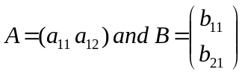

A has the size 1 x 2 and B has the size 2 x 1. The number of columns in A equals the number of rows in B. So we can form the product AB. The result will be a 1 x 1 matrix. We perform the calculation as follows:

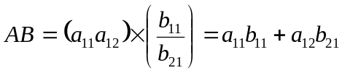

Example 2

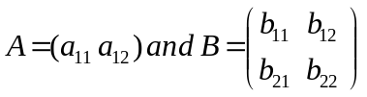
A has the size 1 x 2 and B has the size 2 x 2. The number of columns in A equals the number of rows in B. So we can form the product AB. The result will be a 1 x 2 matrix. We perform the calculation as follows:

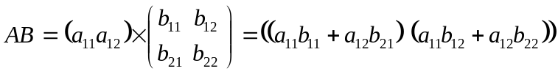

Example 3

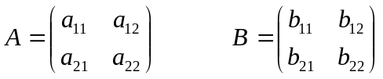

A has the size 2 x 2 and B has the size 2 x 2. The number of columns in A is equal to the number of rows in B. So we can form the product AB. The result will be a 2 x 2 matrix. We perform the calculation as follows:

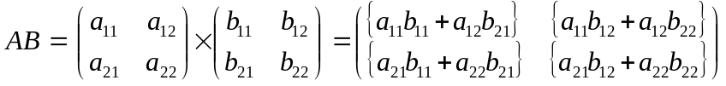

Example 4

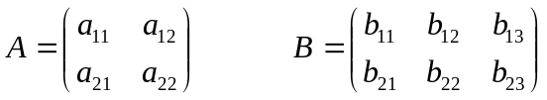

A has the size 2 x 2 and B has the size 2 x 3. The number of columns in A is equal to the number of rows in B. So we can form the product AB. The result will be a 2 x 3 matrix. We perform the calculation as follows:

In general AB does not equal BA and so matrix multiplication is not commutative.

Matrix multiplication is associative: (AB)C = A(BC)

Appendix B – Manual Calculation of Test Matrices

3x3’s matrix multiplications

Input data

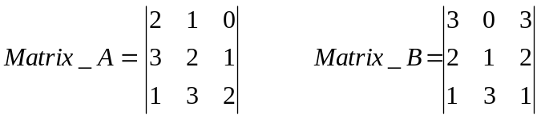 (3x3) by a (3x3) result is a 3x3

Decimal, 1 demensional equivalent of the matrices data 2 1 0 3 2 1 1 3 2 3 0 3 2 1 2 1 3 1
Bit stream 100100111001011110110011100110011101
Split the bit stream up into six bit segments starting with the LSB 100100 111001 011110 110011 100110 011101
Reverse each set of six bits, input into the XSport program 001001 100111 011110 110011 011001 101110
In MATRIX MODE 111/ 011 OR MATRIX MODE 7 / MATRIX MODE 3 the following matrix product is produced

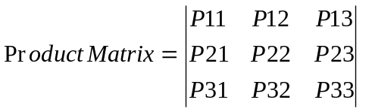
The Calculated matrix product is shown below:-

Calculated Answer:

(2 x 3) + (1 x 2) + (0 x 1) = 8
(3 x 3) + (2 x 2) + (1 x 1) = 14
(1 x 3) + (3 x 2) + (2 x 1) = 11

(2 x 0) + (1 x 1) + (0 x 3) = 1
(3 x 0) + (2 x 1) + (1 x 3) = 5
(1 x 0) + (3 x 1) + (2 x 3) = 9

(2 x 3) + (1 x 2) + (0 x 1) = 8
(3 x 3) + (2 x 2) + (1 x 1) = 14
(1 x 3) + (3 x 2) + (2 x 1) = 11

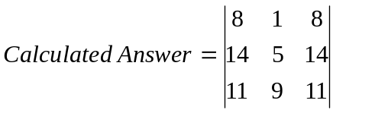

System Answer:

3BFF = 08 3B92 = 01 3BFF = 08
093A = 14 3BEB = 05 093A = 14
0912 = 11 3BFB = 09 0912 = 11

3B92 = 01 – MODE 7
OR
097F = 18 – MODE 3

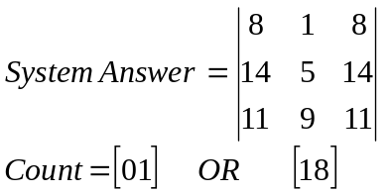
(2x3) by a (3x3) matrix multiplications

Input data

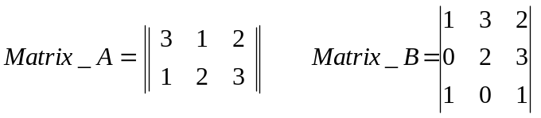 (2x3) by a (3x3) result is a 2x3

Decimal 1 dimensional equivalent of the matrices data 3 1 2 1 2 3 0 0 0 1 3 2 0 2 3 1 0 1
Bit stream 110110011011000000011110001011010001
Split the bit stream up into three bit segments starting with the LSB 110110 011011 000000 011110 001011 010001
Reverse each set of six bits, input into the XSport program 011011 110110 000000 011110 110100 100010

In MATRIX MODE 110 / 010 OR MATRIX MODE 6 / 2 the following matrix product is produced

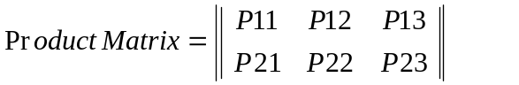

The Calculated matrix product is shown below:-

Calculated Answer:

(3 x 1) + (1 x 0) + (2 x 1) = 5
(1 x 1) + (2 x 0) + (3 x 1) = 4

(3 x 3) + (1 x 2) + (2 x 0) = 11
(1 x 3) + (2 x 2) + (3 x 0) = 7

(3 x 2) + (1 x 3) + (2 x 1) = 11
(1 x 2) + (2 x 3) + (3 x 1) = 11

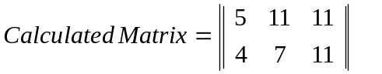

System Answer:

3BEB = 05
3BBA = 04

0912 = 11
3BD2 = 07

0912 = 11
0912 = 11

3B92 = 01 – MODE 6
OR
096B = 15 – MODE 2

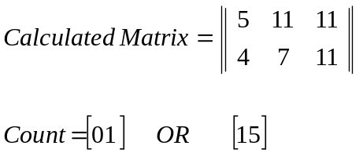
(2x3) by a (3x3) matrix multiplications

Input data

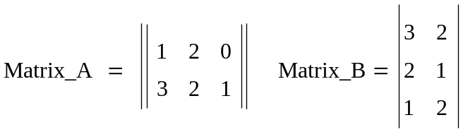 (2x3) by a (3x2) result is a 2x2

Decimal 1 dimensional equivalent of the matrices data 321123000320210120
Bit stream, made up of two bit numbers 111001011011000000111000100100011000
Split the bit stream up into three bit segments starting with the LSB 111001 011011 000000 111000 100100 011000
Reverse each set of six bits, input into the XSport program 100111 110110 000000 000111 001001 000110

In MATRIX MODE 101 / 001 OR MATRIX MODE 5 / 1 the following matrix product is produced


The Calculated matrix product is shown below:-

Calculated Answer:

(1 x 3) + (2 x 2) + (0 x 1) = 7
(3 x 3) + (2 x 2) + (1 x 1) = 14

(3 x 2) + (2 x 1) + (0 x 2) = 4
(1 x 2) + (2 x 1) + (1 x 2) = 10


System Answer:

3BD2 = 07
093A = 14
3BBA = 04
0977 = 10

3B92 = 01 – MODE 5
OR
095D = 12 – MODE 1

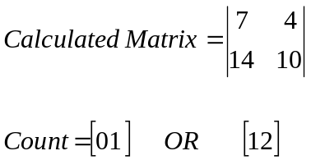

(2x2) by a (2x2) matrix multiplications

Input data

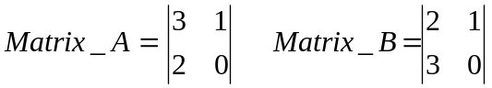 (2x2) by a (2x2) result is a 2x2

Decimal 1 demensional equivalent of the matrices data 310200000210300000
Bit stream, made up of two bit numbers 110100100000000000100100110000000000
Split the bit stream up into three bit segments starting with the LSB 110100 100000 000000 100100 110000 000000
Reverse each set of six bits, input into the XSport program 001011 000001 000000 001001 000011 000000

In MATRIX MODE 100 / 000 OR MATRIX MODE 4 / MATRIX MODE 0 the following matrix product is produced

The Calculated matrix product is shown below:-

Calculated Answer:

(3 x 2) + (1 x 3) = 9
(2 x 2) + (0 x 3) = 4

(3 x 1) + (1 x 0) = 3
(2 x 1) + (0 x 0) = 2
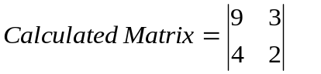

System Answer:

3BFB = 09
3BBA = 04

3BDB = 03
3BDD = 02

3B92 = 01 – MODE 4
OR
3BFF = 12 – MODE 0

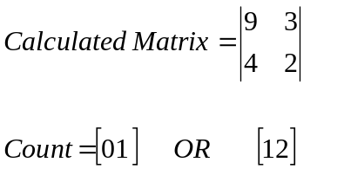

Appendix C – Display Board PCB Templates

